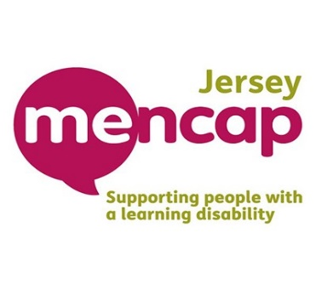

**I’m fundraising with my feet & raising money for   
 Jersey Mencap**

**The South Coast Charity Challenge – 18th May 2025**

**Name........................................................................ Mobile no: .......................................................**

|  |  |  |  |
| --- | --- | --- | --- |
| **Name** | **Contact No:** | **Donation** | **Total Amount** |
|  |  |  |  |
|  |  |  |  |
|  |  |  |  |
|  |  |  |  |
|  |  |  |  |
|  |  |  |  |
|  |  |  |  |
|  |  |  |  |
|  |  |  |  |
|  |  |  |  |
|  |  |  |  |
|  |  |  |  |
|  |  |  |  |
|  |  |  |  |
|  |  |  |  |
|  |  |  |  |
|  |  |  |  |
|  |  |  |  |
|  |  |  |  |
|  |  |  |  |
|  |  |  |  |
|  |  |  |  |
|  |  |  |  |
|  |  |  |  |
|  |  |  |  |
|  |  |  |  |
|  |  |  |  |
|  |  |  |  |
|  |  |  |  |
|  |  |  |  |
|  |  |  |  |
|  |  |  |  |
|  |  |  |  |
|  |  |  |  |
|  |  |  |  |
|  |  |  |  |
|  |  |  |  |
|  |  |  |  |
|  |  |  |  |
|  |  |  |  |
|  |  |  |  |
|  |  |  |  |
|  |  |  |  |
|  |  |  |  |
|  |  |  |  |
|  |  |  |  |
| **Total amount raised:** | ***THANK YOU FOR YOUR SUPPORT*** |  | **£** |

All the money raised will be used to provide people with a learning disability more choice and opportunity through our much-needed projects!